**Year 11 ATAR Chemistry**

Task 10: Intermolecular Forces & Solubility Test

Weighting: 5% of Year Grade

NAME: ______________________________

TEACHER’S NAME: ___________________

**Required Resources:**

Blue or Black pen, Ruler, Calculator, Chemistry Data Book

**Not Allowed:**

Notes, Personal Periodic Tables

|  |  |  |  |
| --- | --- | --- | --- |
| **SECTION** | **NUMBER OF QUESTIONS** | **AVAILABLE MARKS** | **MARK** |
| Multiple Choice | 10 | 11 |  |
| Short Answer | 10 | 37 |  |

**SECTION A: MULTIPLE CHOICE SECTION (15 marks)**

INSTRUCTIONS

For each question, shade the box to indicate your answer. Use only a blue or black pen to shade the boxes. For example, is b is your answer:

If you make a mistake, place a cross through the square and shade your new answer, for example d:

If you then want to use your first answer b, cross out d and circle b:

1. Which of the following molecules would have the highest boiling point?
   1. Phosphorus pentachloride (PCl5)
   2. Cyclohexane (C6H12)
   3. Propan-1-ol (CH3CH2CH2OH)
   4. Hydrobromic acid (HBr)
2. Which of the following statements is incorrect when describing carbon dioxide?
   1. Carbon dioxide contains polar bonds
   2. Carbon dioxide molecules are held together by dipole-dipole forces
   3. Carbon dioxide is a non-polar molecule
   4. The central atom in carbon dioxide has no lone pairs of electrons
3. The bond angle between each of the four hydrogen atoms in methane is 109o. Why is this?
   1. It is the only way that hydrogen atoms will fit around the carbon atom
   2. The spacing of the hydrogen atoms makes it easier for them to form intermolecular forces with other atoms
   3. The electron pairs around the carbon atom repel each other, maximising the distance between them
   4. It maximises methane’s polarity
4. A molecule with a shape that is trigonal pyramidal has:
   1. 4 bonding pairs of electrons
   2. 3 bonding pairs of electrons
   3. 4 bonding pairs of electrons and one lone pair of electrons
   4. 3 bonding pairs of electrons and one lone pair of electrons
5. The mobile phase for a chromatographic separation is:
   1. The phase that carries the sample mixture over the stationary phase
   2. The phase that separates the components of a mixture
   3. The phase that is separated in the technique
   4. The phase that is always polar in composition
6. Which of the following statements is incorrect?
   1. A substance can contain polar bonds but be non-polar overall
   2. A substance that is geometrically symmetrical is always polar
   3. Elemental molecules are always non-polar
   4. A polar molecule can form attractions to ions
7. The two molecules shown below are similar in molecular structure in mass:

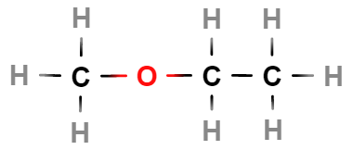 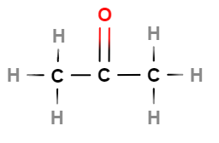

methoxyethane acetone

Each molecule contains three carbon atoms and one oxygen atom, however methoxyethane has a boiling point of 6.8oC and acetone has a boiling point of 56oC. What is a correct explanation of this?

1. The oxygen atom in methoxyethane is not as accessible for hydrogen bonding
2. Oxygen atoms that form single bonds do not hydrogen bond with other molecules
3. Acetone is a shorter molecule which allows it to form more intermolecular forces
4. The more hydrogen atoms a molecule has, the lower the boiling point
5. Which of the following three molecules will have the lowest vapour pressure?

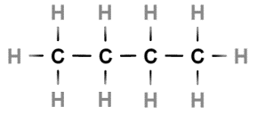

* 1. Butane
  2. Methylpropane
  3. Cyclobutane
  4. They will all have the same vapour pressure

1. The following two molecules will form which of the following intermolecular forces with each other?

Ammonia Ethanol

1. Dipole-dipole forces and hydrogen bonds
2. Dispersion forces and hydrogen bonds
3. Hydrogen bonds
4. Dispersion forces, dipole-dipole forces and hydrogen bonds
5. Which of the following molecular shapes has three electron groups around the central atom?
   1. Tetrahedral
   2. Trigonal pyramidal
   3. Trigonal planar
   4. Both trigonal pyramidal and trigonal planar
6. Increasing the temperature of a solution will cause the solubility of a gas to:
7. Decrease
8. Increase
9. Remain constant
10. Randomly fluctuate

**SECTION B: SHORT ANSWER SECTION (37 marks)**

1. Draw the Lewis structures for the following substances:

|  |  |
| --- | --- |
|  |  |
| Sulfur dichloride (SCl2) | Calcium nitride |
|  |  |
| Ammonium chloride | Hydrogen cyanide (HCN) |

(4 marks)

1. Identify the following molecular shapes and provide one example of a molecule with that shape.

|  |  |  |
| --- | --- | --- |
| Name of shape | Diagram of molecule | Example of molecule |
| Tetrahedral |  |  |
| Trigonal pyramidal |  |  |
| Bent |  |  |

(6 marks)

1. The following graph shows the boiling points of simple covalent compounds that include hydrogen. One line represents the trend in boiling point of the group 6 elements and the other represents the trend in boiling point of the group 7 elements.

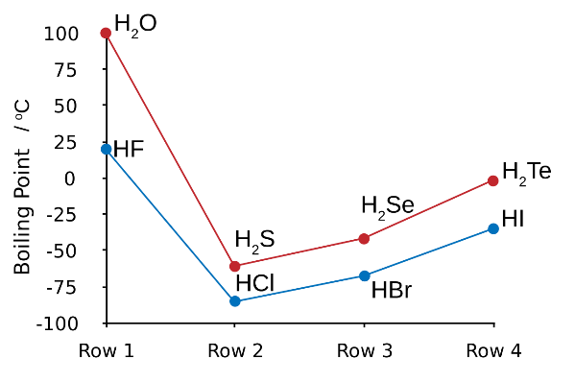

* 1. Explain why HF has a much higher boiling point than HCl, HBr and HI. (1 mark)

|  |
| --- |
|  |
|  |

* 1. Explain the increase in boiling point from HCl to HI. (2 marks)

|  |
| --- |
|  |
|  |
|  |
|  |
|  |

1. Draw two diagrams:
   1. One that shows the interaction of a potassium ion with a water molecule in solution.
   2. One that shows the interaction of a chloride ion with a water molecule in solution.

|  |  |
| --- | --- |
|  |  |
| Potassium ion in solution | Chloride ion in solution |

(4 marks)

1. Propane is a gas which is used in gas hotplates whilst pentane is a liquid component of gasoline. Using your knowledge of intermolecular forces, explain why these compounds exist in different states at room temperature. (3 marks)

|  |
| --- |
|  |
|  |
|  |
|  |
|  |

1. What is vapour pressure? Explain how this property relates to the strength of intermolecular forces. (3 marks)

|  |
| --- |
|  |
|  |
|  |
|  |
|  |

1. High performance liquid chromatography (HPLC) has many useful applications, with one of the most common being in the monitoring and analysis of additives used in food and beverages. A common additive found in many low-calorie food and drink products is the artificial sweetener known as ‘aspartame’. The safety of aspartame has been studied extensively over the years, with many people reporting side effects such as nausea, dizziness, and abdominal pain. Whilst it is still classified as a ‘safe substance’ by various food and health organisations, many people choose to avoid aspartame consumption.

A chemist decided to run some tests to compare the aspartame levels found in four different types of soft drink, and she used HPLC to perform the analysis.

* 1. Describe how column chromatography techniques are able to separate the components of a sample, in particular focussing on the role of polarity in the process. (2 marks)

|  |
| --- |
|  |
|  |
|  |
|  |
|  |
|  |
|  |
|  |

The chemist used previous HPLC data to produce the ‘control’ chromatogram shown below, which displays the retention times for several common soft drink additives, including aspartame.

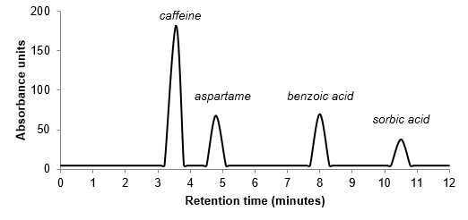

She then ran HPLC analysis on samples of four (4) different soft drinks; Pepsi, Diet Pepsi, Pepsi Max and Fanta Orange. The individual chromatograms for each soft drink are shown below. You may assume they were carried out under the same HPLC conditions as the ‘control’ above.

* 1. Which of the soft drinks contained aspartame? Name the drink with the highest aspartame concentration. (2 marks)

|  |
| --- |
|  |
|  |
|  |
|  |

1. For the following reactants:
   1. Produce a balanced chemical equation.
   2. Determine whether or not there will be a precipitate. (6 marks)

|  |  |
| --- | --- |
| **Ammonium bromide reacting with silver nitrate.** | |
|  | |
| Will there be a precipitate? |  |
| **Chromium (III) chloride reacting with sodium sulphate.** | |
|  | |
| Will there be a precipitate? |  |

1. Explain why glaciers which are extremely heavy are able to float in liquid water. (2 marks)

|  |
| --- |
|  |
|  |
|  |
|  |
|  |

1. Use a diagram to show how sodium fluoride (NaF) interacts with water molecules when in solution.

(2 marks)

|  |
| --- |
|  |

**END OF TEST**

Extra working space: